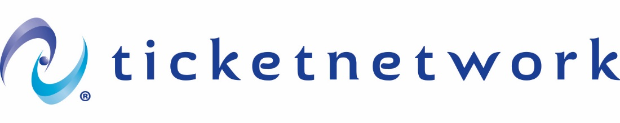
API Client devportal Guide
Zx7910
7/24/2026
Version 4.0 | TicketNetwork Support

API Client devportal Guide
Contents
Overview 2
Logging into the devportal 2
Logging out of the devportal 3
Viewing API Documentation 4
Documentation (Supplemental) 4
Swagger UI and Postman collection 5
Trying out APIs 6
API Try Out 6
Subscribing to New APIs 8
Subscribing Through the “APIs” tab 9
Subscribing Through the “applications” tab 10
Adding a new application 12
Creating access token 13
Reporting an issue with the DevPortal account or API………………………………….……………………….16

Overview
This document contains instructions on how to use TicketNetwork’s API DevPortal to view API documentation and use a TestApplication try out APIs through DevPortal in Sandbox.

Logging into the devportal
Navigate to https://console.tn-apis.com/devportal/ and log in to your account using the “Sign-In” link located in the top menu to the far right. If you are already logged in your username will appear here instead of the “Sign-In” link.
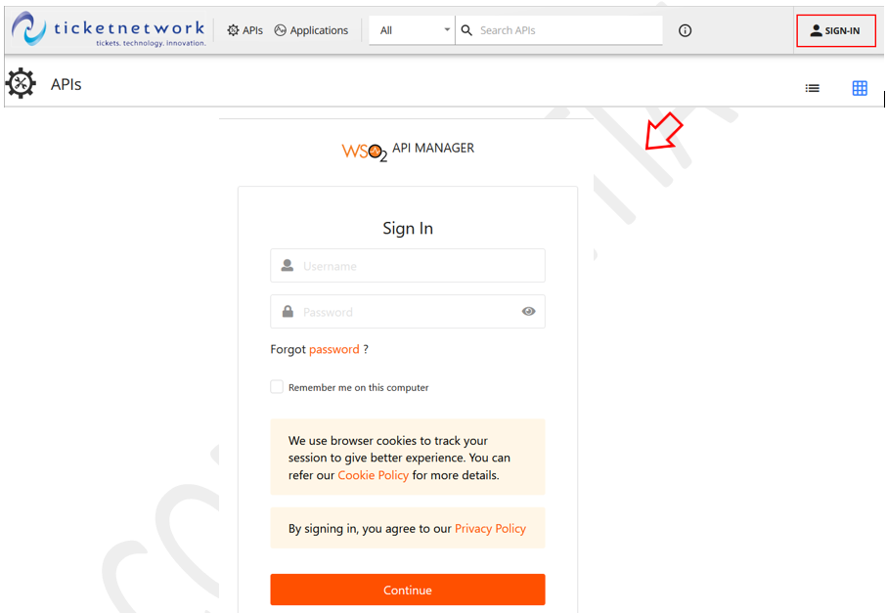

Your DevPortal Login
Username | Zx7910-store
Password | ^T!^&D1R^Zlr

You will not be able to view any APIs or their documentation unless you are logged into your account.

Logging out of the devportal
If you wish to log out of the DevPortal, you can do so by clicking on your username in the top menu on the far right. A popover will appear with a link to “Logout”, which can be used to end your devportal session.
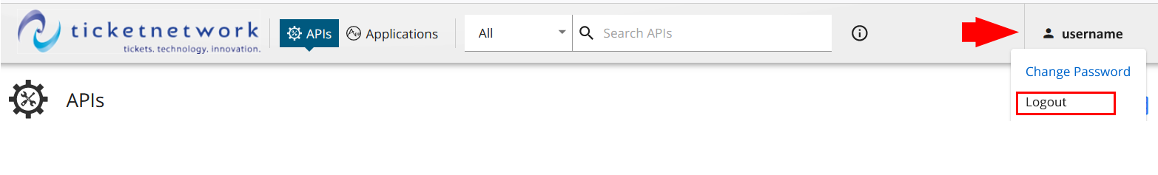viewing APIs
Right after you log in into the devportal account you’ll see all API’s you have access to. You can use a search to look for an API. You can review an API if you click on it.
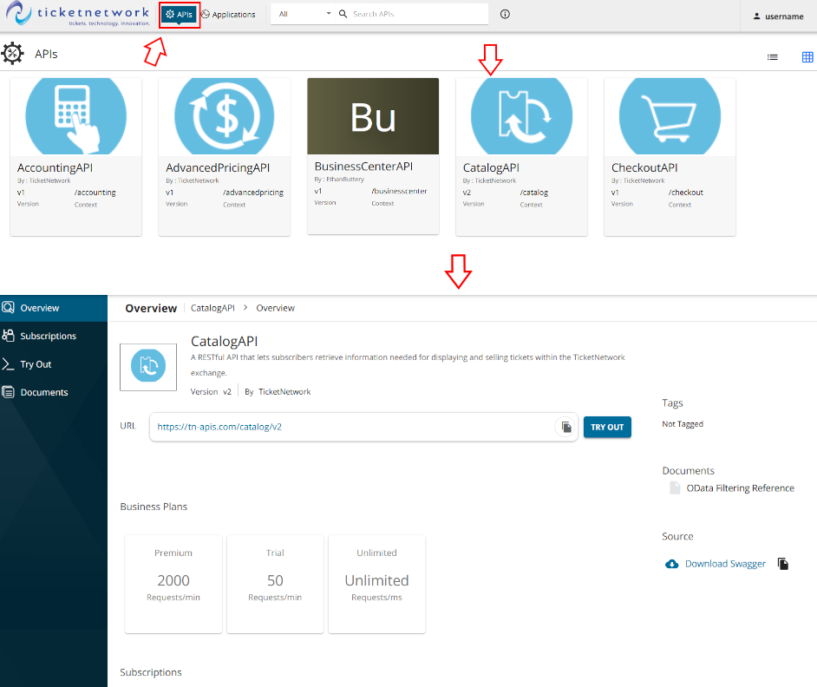

Viewing API Documentation
All API documentation is available directly in the DevPortal. This documentation can be used to gain an understanding of what resources each API offers and start planning your API integration. Supplemental materials, such as a Client Integration Guide, will also be provided during the start of the integration process.
To view the documentation for an API, navigate to the “Documents” tab on the API’s page in the DevPortal via the APIs link in the left menu.
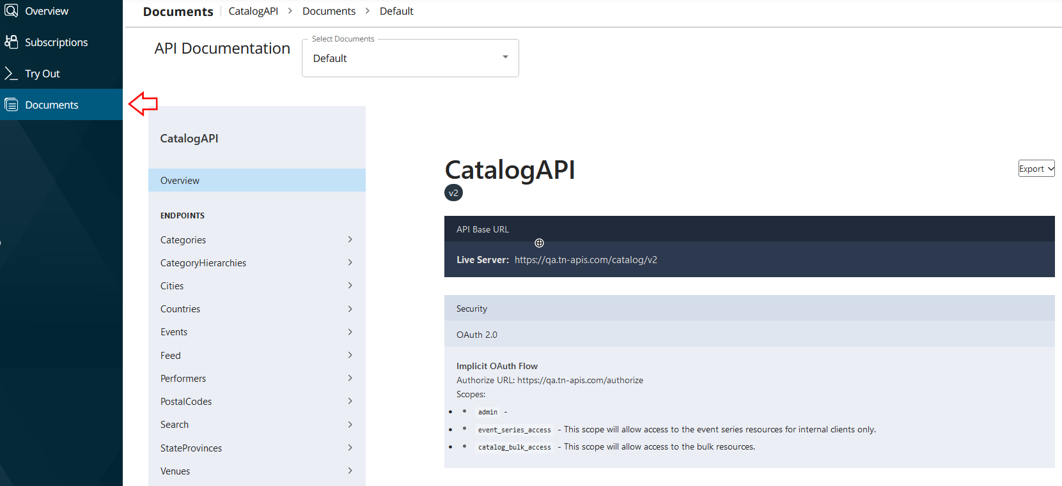

Documentation (Supplemental)
The “Documents” tab contains additional information that is useful for integrating with the API, ranging from workflows and samples, to test cases and details on expected URL parameter syntax.
Use the API Documentation dropdown on the Documents tab to switch between documents.
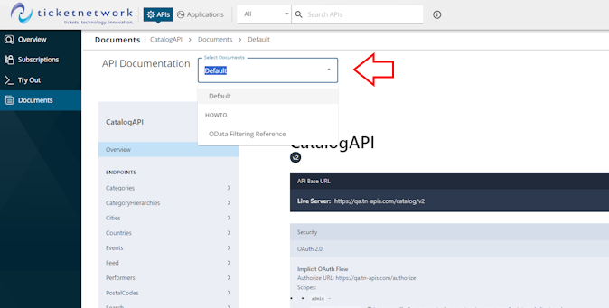

Swagger UI and Postman collection
The “Try out” tab contains Swagger UI documentation that defines the structure of the API and its responses and Postman collection. Also, Swagger UI documentation can be downloaded directly from the API Overview or Try Out pages:
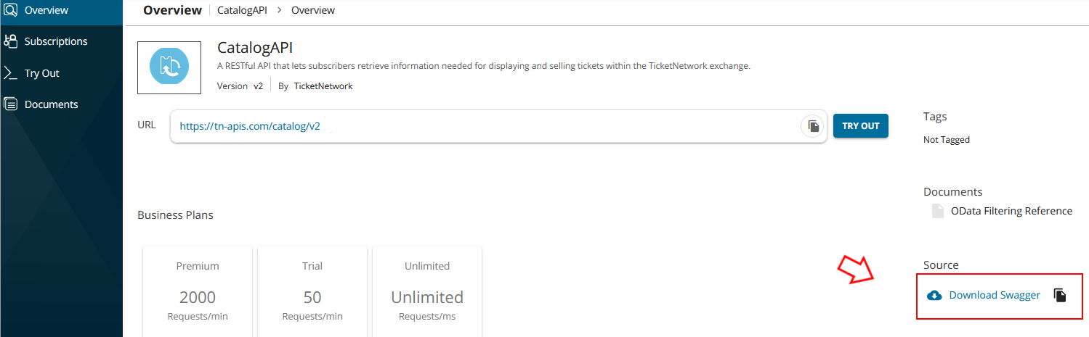
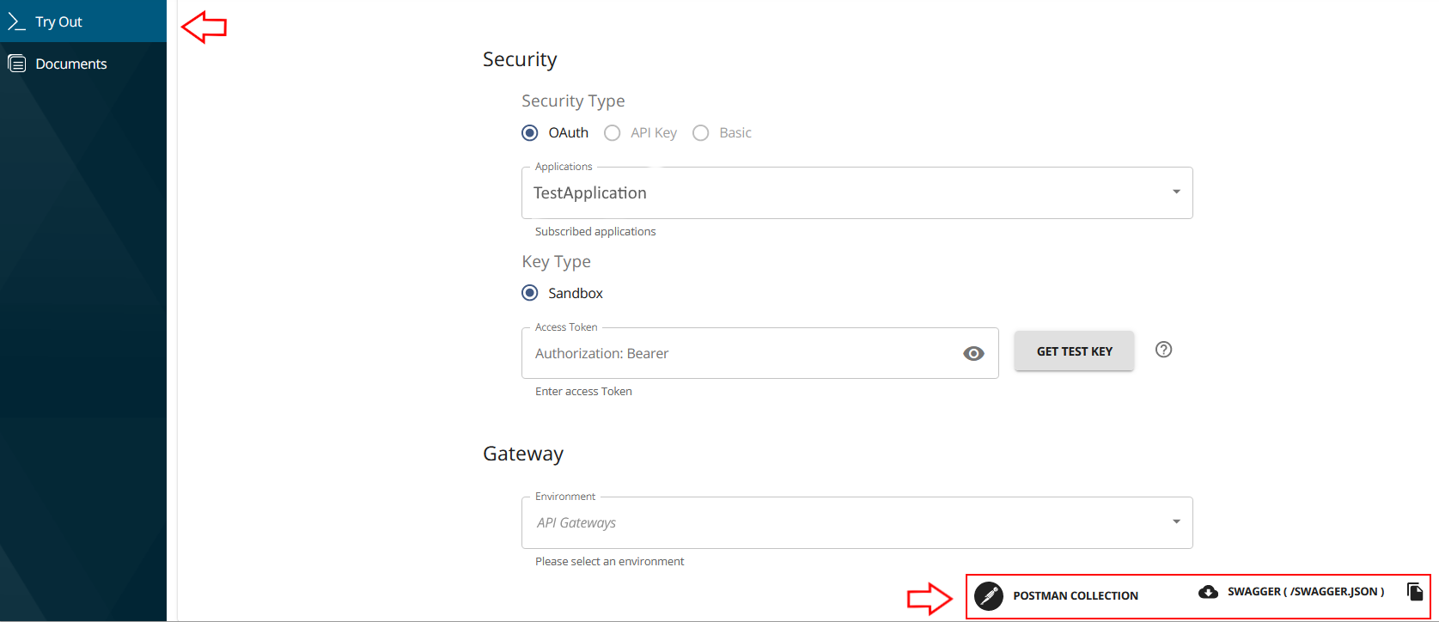

Trying out APIs

API Try Out
You can try out calls to APIs you are subscribed to within the DevPortal by navigating to the API’s page and selecting the API you want to use, then going to the “Try Out” tab.
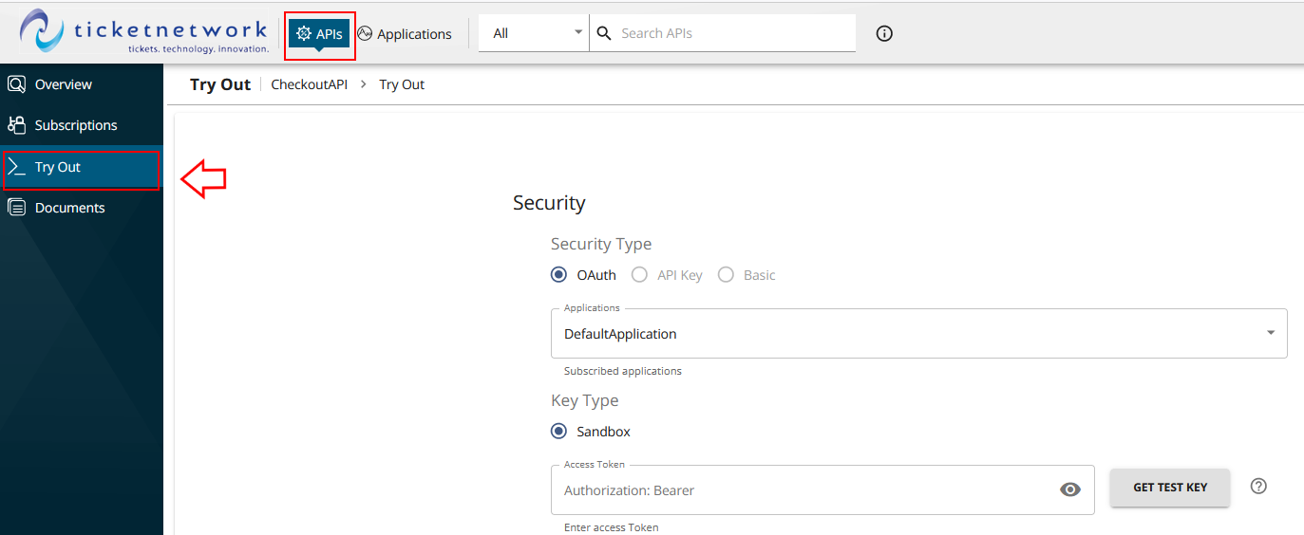
- Choose “TestApplication” by select Applications dropdowns.
- Enter your Access Token:
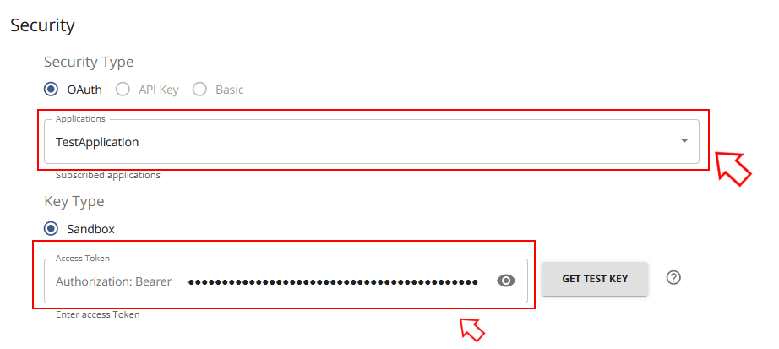

Important! You cannot get your Access Token by using the Get Test Key button. DO NOT USE this button. It will override your Access Token.

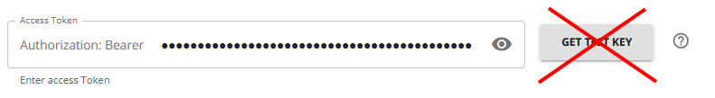
- Expand the resource that you want to try by clicking on the resource path.
Note! In the UI, the Parameter fields will be disabled and the “Execute” button will be hidden by default. To enable the fields and show the “Execute” button click on the “Try it out” button:

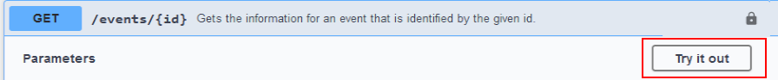

- Fill out the request parameters.
- Click the “Execute” button.
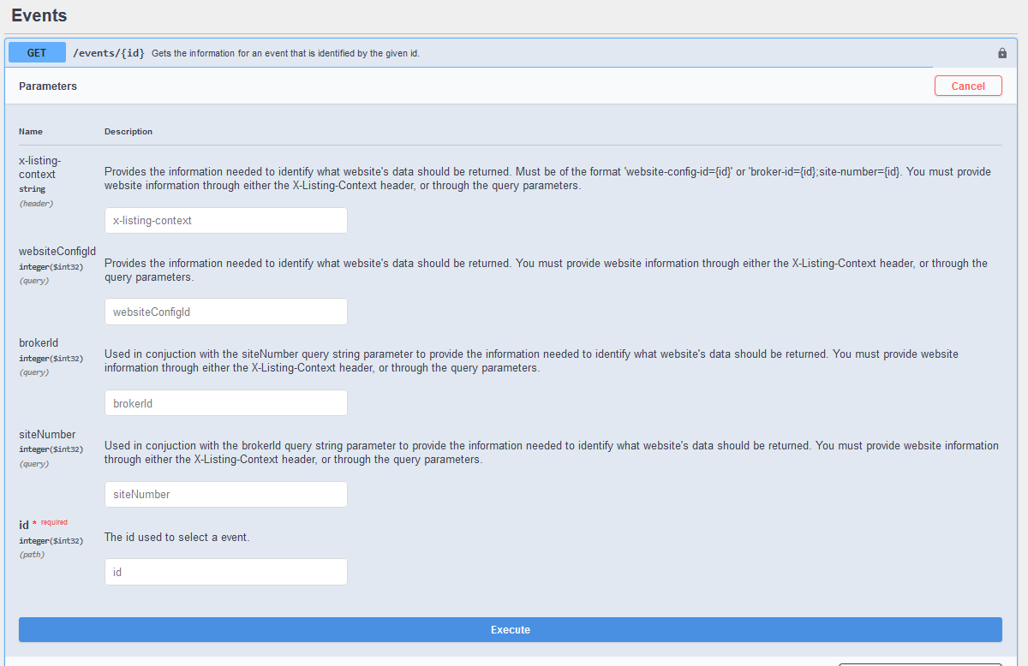

Subscribing to New APIs
The TicketNetwork APIs are hosted in two environments: Sandbox and Production. The Sandbox environment is built for integration and testing, and the Production environment is for live traffic. You CANNOT create Production tokens in the DevPortal. TN WebSupport will provide you with all Production keys when your application will be ready to move too Production.
A TestApplication has been created for you which you can use to try out our APIs in the Sandbox environment. Subscription to Catalog API has already been added for your TestApplication, and requests against resources associated WCID 12498 for ONLY Catalog API in Sandbox are allowed. If you want to try out any of the other APIs available to you, you can do so by subscribing to those APIs as well.

subscribing Through the “APIs” tab
- Navigate to the API you want to subscribe to via the APIs tab in the top menu.
- Click on “Subscriptions” in the right menu.
- Select TestApplication in the “Applications” dropdown. If your TestApplication is already subscribed to this API it will not show up in the list.
- Choose the Trial subscription tier in the “Tier” dropdown. The tier controls the throttling applied for this subscription.
- Click the “Subscribe” button.

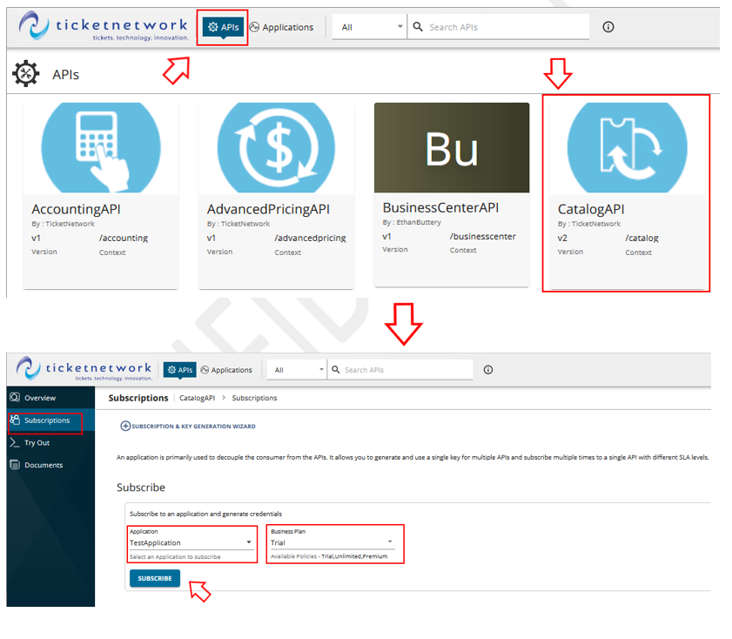

Subscribing Through the “applications” tab
- Navigate to the Applications tab in the top menu.
- Click on the application you want to subscribe.
- Select Subscriptions from the left menu.
- Click on ⊕SUBSCRIBE APIS
- Choose the API by the search or by the page selection.
- Click Subscribe.

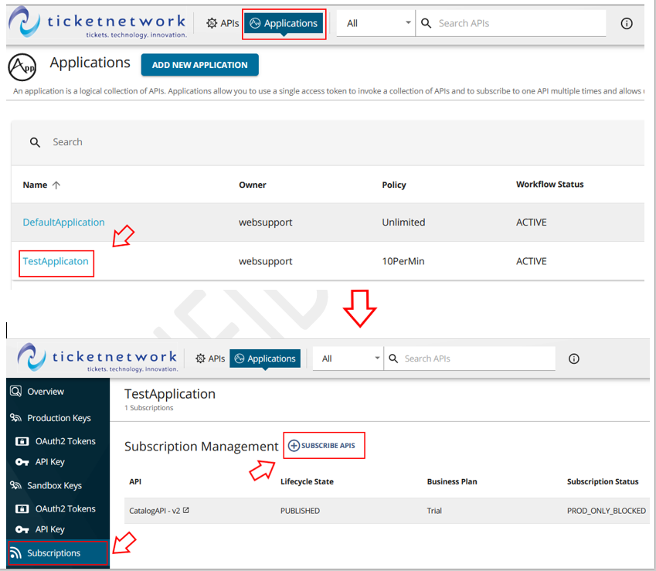

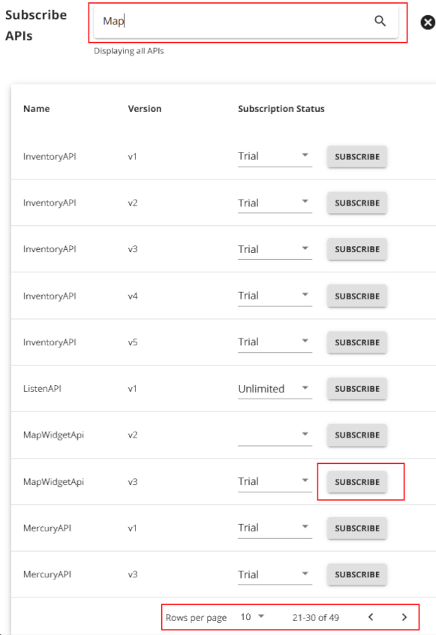
After subscribing to an API, it will only be available to you in the Sandbox environment. You can view and manage your current subscriptions through the “Applications” tab.

adding a new application
A non-expiring Sandbox application API Key has already been generated for your TestApplication. This single key is used to authenticate the TestApplication against all the APIs it is subscribed to.
However, if you want to create a new application and generate tokens for it, then under the Applications tab you need to click on the ADD NEW APPLICATION tab.

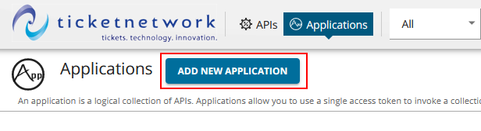
Then enter the name and choose a request quota. Click SAVE.
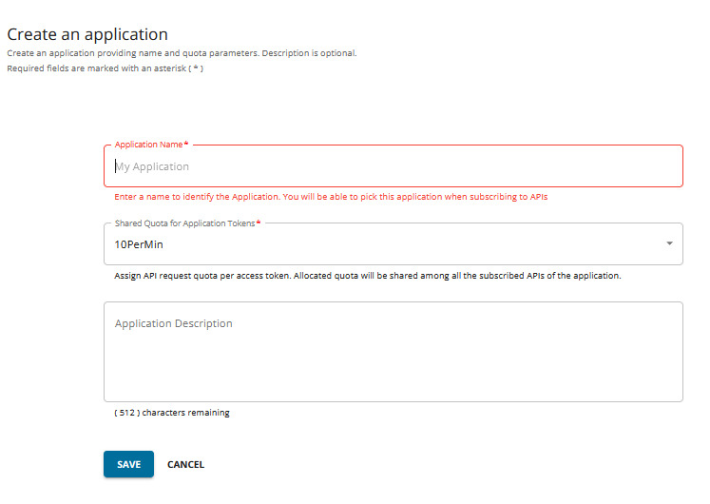

creating access token
Tokens can be generated if you go to the “Applications” tab at the top menu, then to Sandbox Keys > OAuth2 Tokens in the left menu:
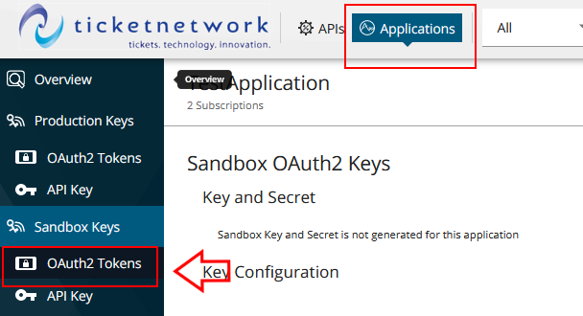
If this is a new application, you will need to Generate Keys for your application before generating a token. Scroll all the way down to the bottom of the page and click the “Generate Keys” button.
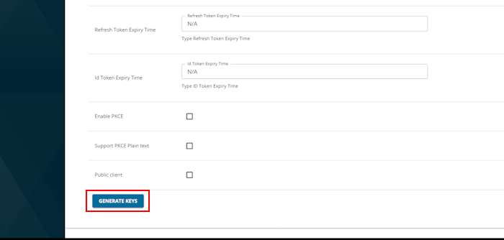

If this is a new application, you will need to Generate Keys for your application before generating a token. Scroll all the way down to the bottom of the page and click the “Generate Keys” button.


Generated Consumer Key and Consumer Secret will appear at the top of the page:
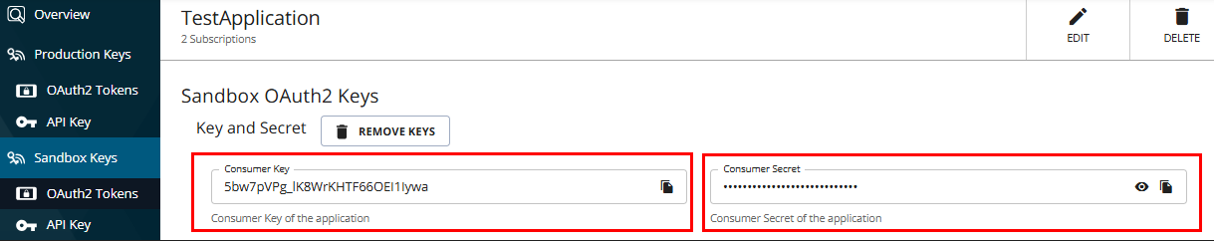
After generating your application keys, you will need to set up an expiration for the token before you generate the token.

To generate a token that expire in one hour use 3600 seconds. Click “Update” at the bottom of the page to save it.

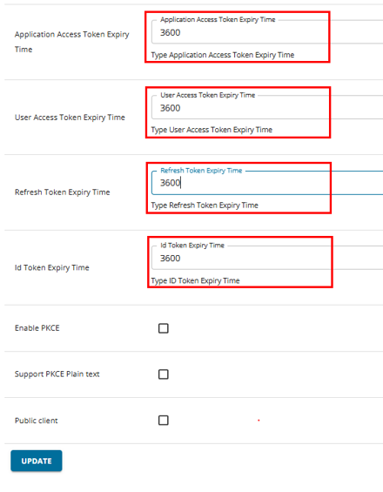
You do not need to change anything for the Grant Types, Enable PKCE, Support PKCE Plain text and Public client checkboxes. Leave it as it is by default.

You have to generate your access token. Please take a look at the following document. API+Authorization.pdf (tn-release.s3.amazonaws.com)

REPORTING AN ISSUE WITH THE DEVPORTAL ACCOUNT OR API

If you have any issue with accessing your Devportal account or you are getting any errors in using any API’s or your application, you can report an issue sending email directly to IntegrationSupport@ticketnetwork.com or to IntegrationSupport-FD@ticketnetwork.com (this will automatically create a ticket for your request).

Make sure you have a proper subject:

SUBJECT: WCID / DevPortal Account Name

Include some or all the following details:

1. Description of All Issues
(Please describe every issue you are experiencing, including expected vs. actual behavior.)
2. Endpoint(s) Involved
(Endpoint name and Environment - Sandbox or Production).
3. Full Request
(Include the entire request exactly as sent — URL, X-Identity-Context, headers, parameters, and body.)
4. Full Response
(Include the entire response exactly as received — status code, headers, and body.)
5. Additional Relevant Information
(Examples: timestamps, logs, screenshots, steps to reproduce, recent changes, etc.)

